Report: Optimizing NYC Taxi Operations

1. Introduction
This report presents an exploratory data analysis of NYC Yellow Taxi trip data for the year 2023. The objective of this analysis is to understand travel patterns, passenger behavior, fare trends, and operational insights that can help improve taxi services.

2. Data Description
The dataset contains Yellow Taxi trip records including pickup and dropoff date and time, pickup and dropoff locations, trip distance, passenger count, fare amount, tips, and surcharges. The data was provided in Parquet format and monthly files were available for the year 2023.
Assumptions:
1) The analysis was performed on a sampled version of the dataset due to large data size.
2) Only NYC Yellow Taxi trip data from the year 2023 was considered.
3) Trips with invalid or inconsistent values were removed during data cleaning.
4) Zero-distance trips were handled carefully and excluded where necessary.
5) Pickup location was assumed as the trip origin for zone-level analysis.
6) Fare and tip analysis was based only on valid fare values.

3. Data Cleaning
Data cleaning was performed to ensure accuracy and consistency. Missing values were handled appropriately, invalid records such as negative fares and incorrect passenger counts were removed, and outliers were treated to avoid skewed analysis results.

4. Exploratory Data Analysis
Exploratory analysis showed clear demand patterns across time and locations. Taxi pickups were highest during weekday morning and evening peak hours. Weekend demand was more evenly distributed throughout the day.

Figure: Daily taxi pickup trends:
Taxi pickups are higher on weekdays compared to weekends, indicating stronger demand during regular working days.

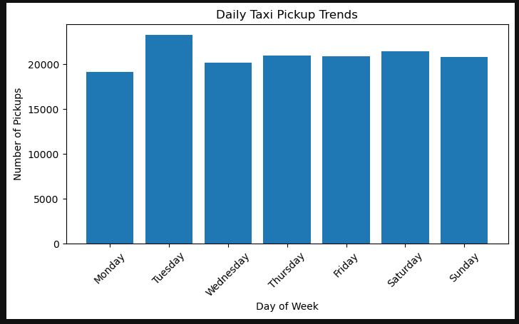

Figure: Monthly taxi pickup trends (sampled data):
Taxi pickups show variation across months, reflecting seasonal changes in travel demand during the year.

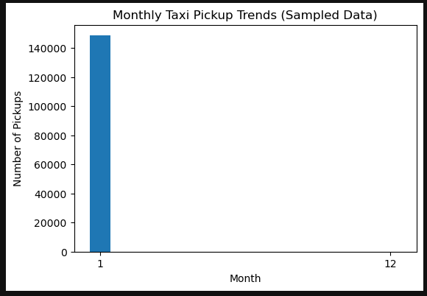

Figure: Quarter-wise revenue proportion (sampled data)
Revenue contribution varies across quarters, with certain quarters contributing a larger share of total taxi revenue.

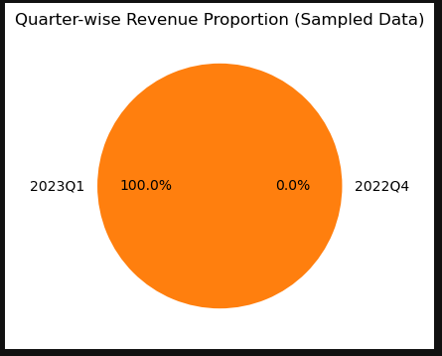
Figure: Relationship between trip distance and fare amount:
Fare amount increases as trip distance increases, showing a clear positive relationship between distance and fare.

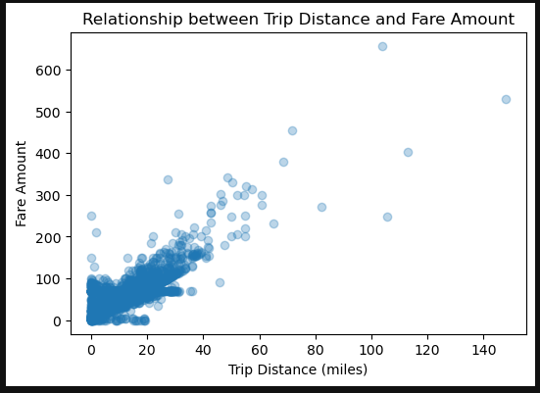

Figure: Fare amount vs trip duration:
Fare amount generally increases with trip duration, indicating that longer trips tend to result in higher fares.
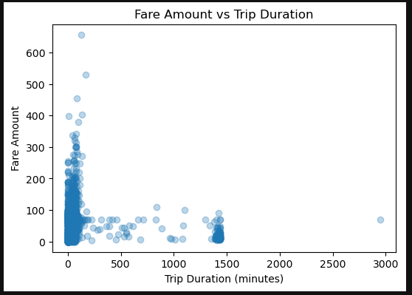
Figure: Fare amount vs passenger count:
Fare amount does not change significantly with passenger count, indicating that fares are mainly driven by distance and time rather than the number of passengers.

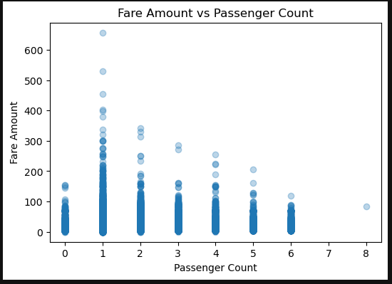
Figure: Tip amount vs trip distance:
Tip amount generally increases with trip distance, indicating that longer trips tend to receive higher tips.
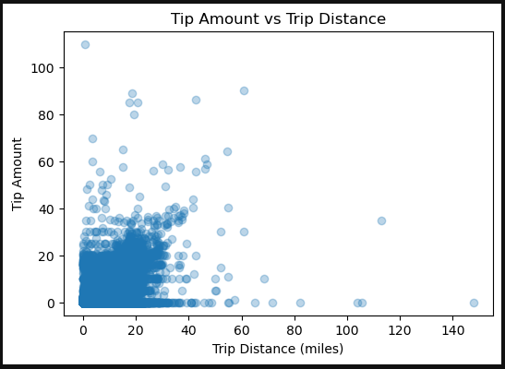
Figure: Distribution of payment types:
Credit card payments are the most common mode of payment, followed by cash, while other payment types occur less frequently.

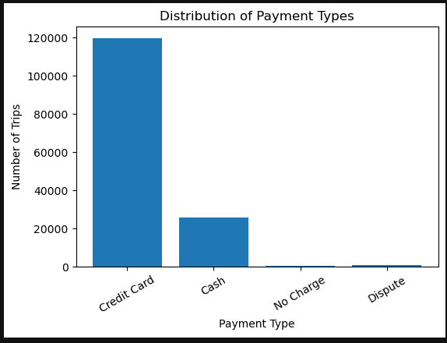

5. Geographical Analysis
Geographical analysis using taxi zone shapefiles revealed that a small number of zones, mainly in Manhattan and airport areas, account for a large share of taxi trips. Night-time pickup zones differed from daytime pickup zones.

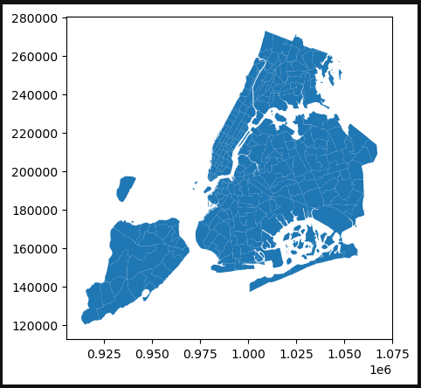

Figure: Zone-wise taxi pickup distribution:
Taxi pickups are highly concentrated in a few zones, mainly in central city areas and airport regions, indicating uneven spatial demand.

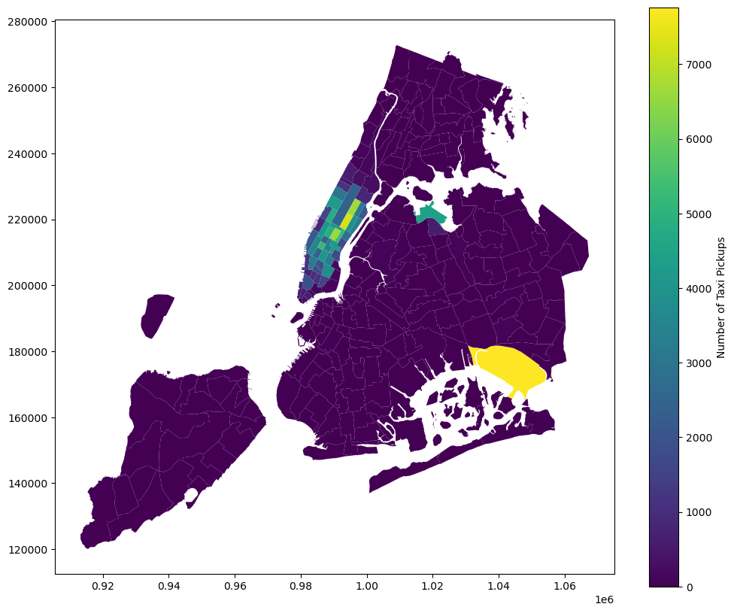
Figure: Number of taxi trips per hour:
Taxi trips are highest during morning and evening peak hours, reflecting strong commuter travel demand.
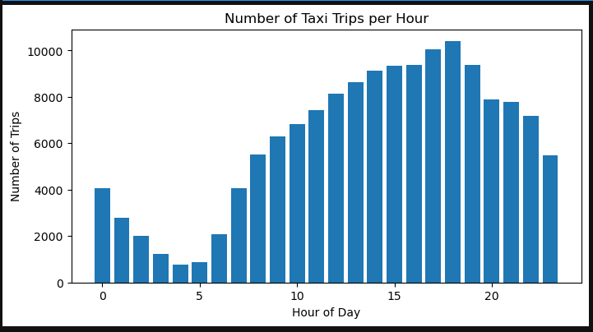
Figure: Weekday vs weekend traffic trends:
Weekday traffic shows clear morning and evening peaks, while weekend traffic is more evenly distributed across the day.

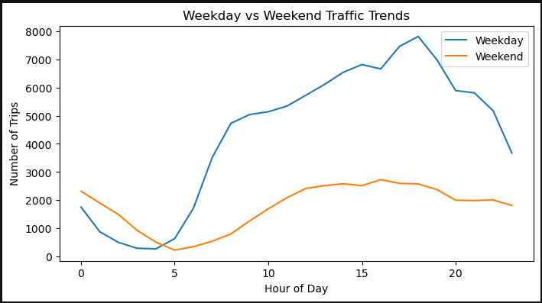

Figure: Hourly pickup trends for top 10 pickup zones:
The top pickup zones show distinct hourly demand patterns, with higher activity during peak hours compared to other times of the day.

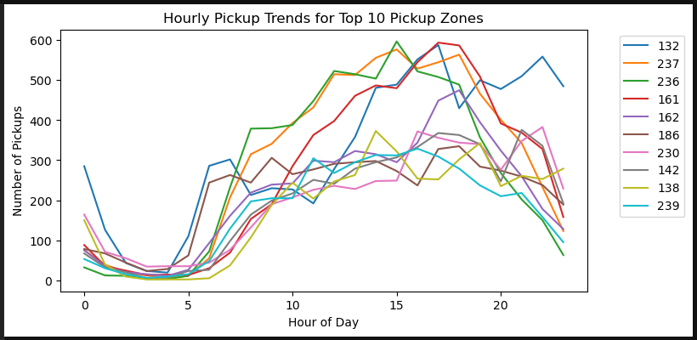

Figure: Average passenger count by hour of day:
Average passenger count varies across the day, with slightly higher values during peak and leisure travel hours.

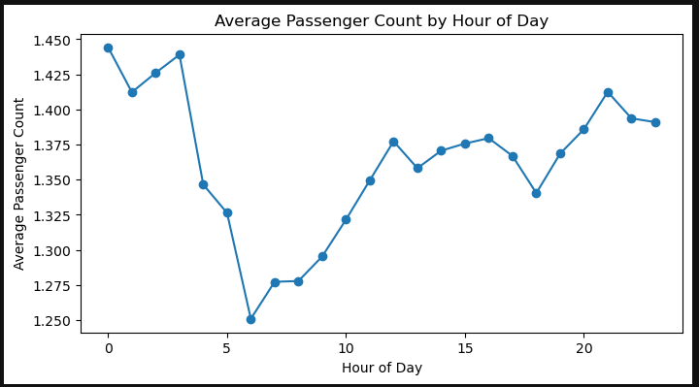

Figure: Average passenger count by day of week:
Average passenger count shows small variation across days of the week, with slightly higher values during weekends.

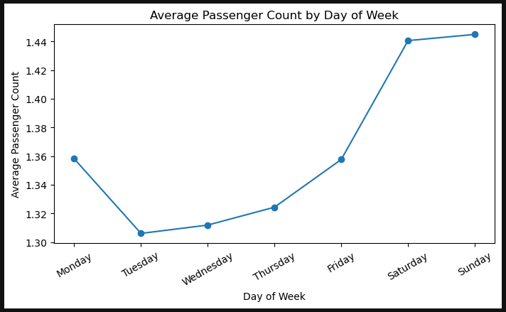

6. Pricing and Revenue Analysis
Revenue analysis indicated higher earnings during peak and late-night hours. Fare per mile varied based on trip distance, time of day, and passenger count. Longer trips generally resulted in higher total fares and tips.
Figure: Average fare per mile by hour of day:
Average fare per mile is higher during peak and late-night hours, indicating the impact of demand and traffic conditions on pricing.

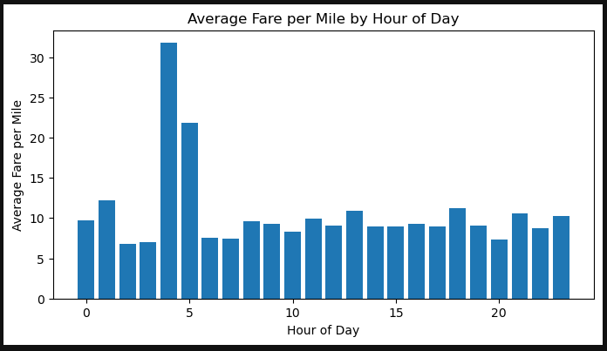
Figure: Average fare per mile by day of week:
Average fare per mile shows variation across different days of the week, reflecting changes in demand and traffic conditions.

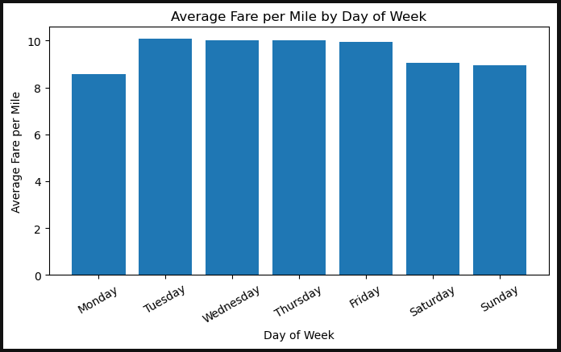

Figure: Vendor-wise fare per mile across distance tiers:
Fare per mile varies across distance tiers and vendors, showing differences in pricing patterns for short, medium, and long trips.

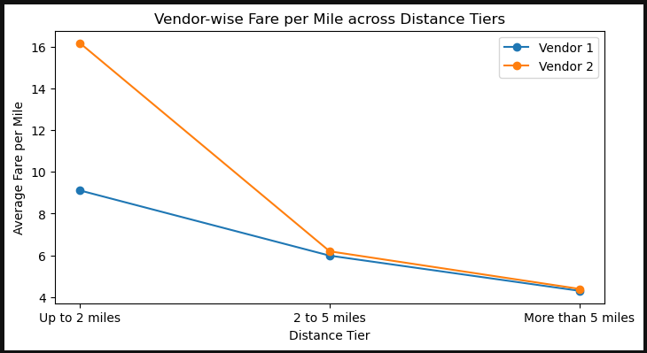

7. Conclusion and Recommendations
Based on the analysis, taxi operations can be improved by better fleet positioning during peak hours, focusing on high-demand zones, and using data-driven pricing strategies. These measures can help reduce passenger waiting time and improve overall service efficiency.

